RCM User Guide

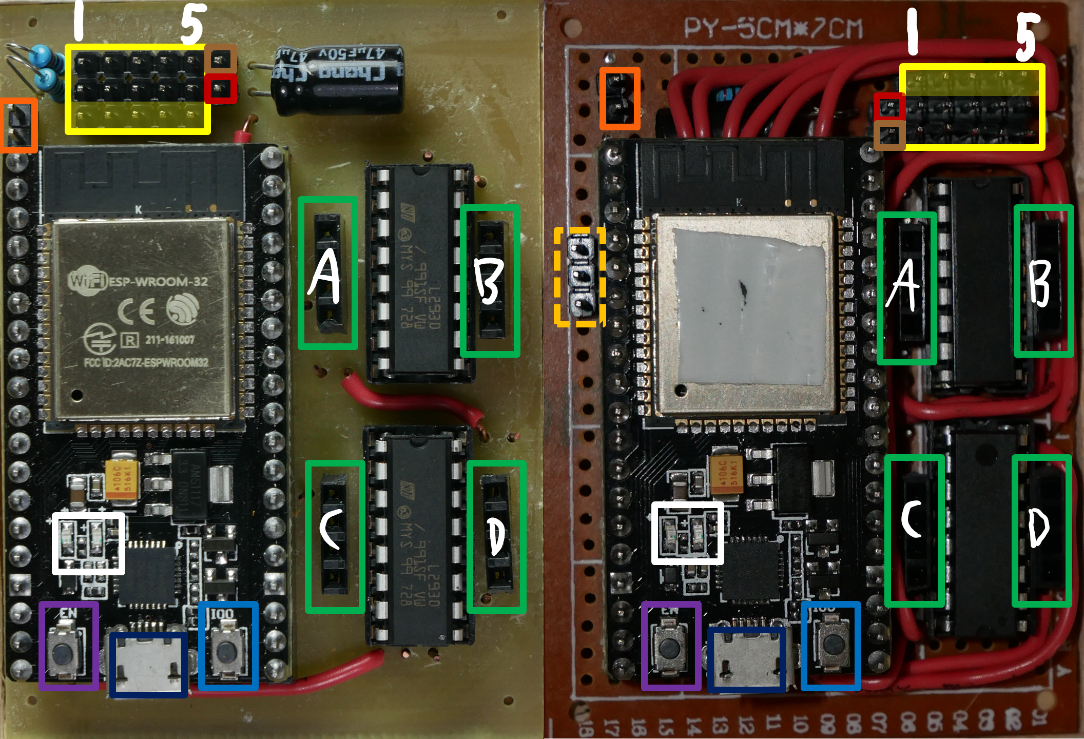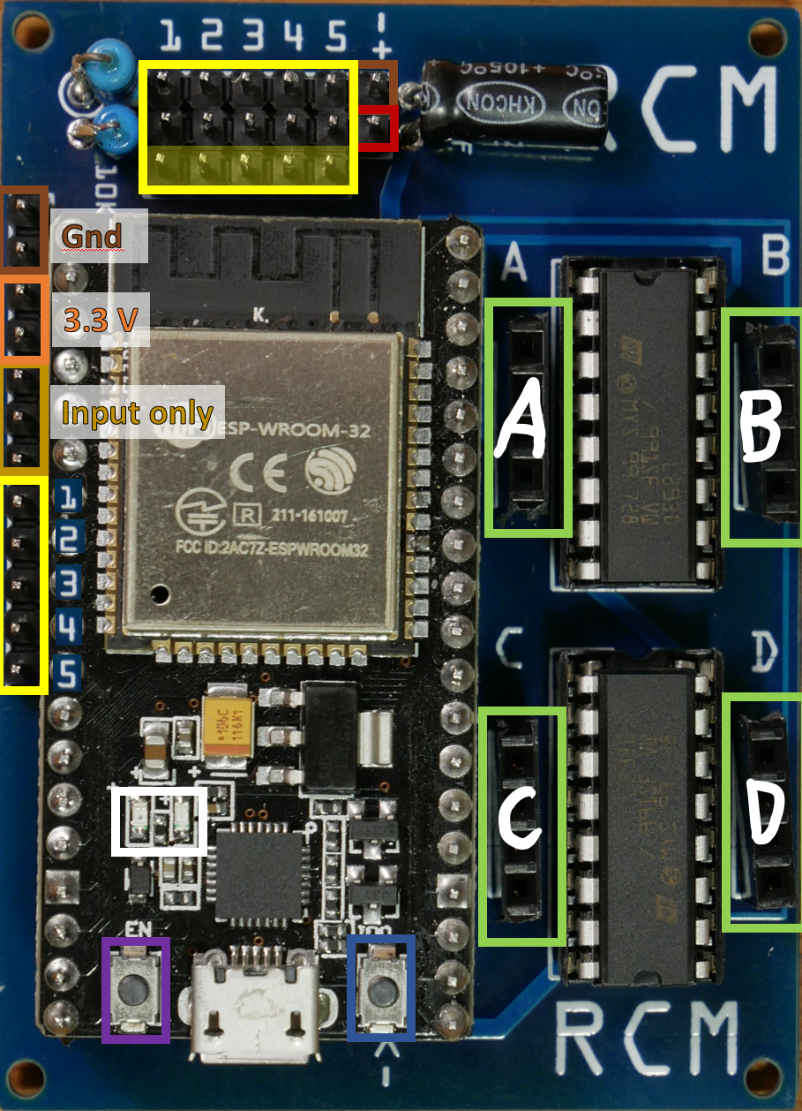

* 4 motor control ports. The top two and bottom two pins of each port are connected together so two motors can be plugged into each port. The motor drivers can supply 0.6 A on each port continuously with a burst of 1.2 A ([L293D datasheet](https://www.ti.com/lit/ds/symlink/l293.pdf)) Left to right then down in the above pictures, the ports are called portA through portD in the code.
* 5 servo ports. Each servo port has a ground pin, battery power pin, and connection to a signal pin. The signal pins are shaded yellow in the above pictures, and should connect to the signal wire of a servo which is usually white or orange. Left to right in the above pictures the ports are called port1 through port5 in the code. You don’t have to connect servos to these ports, you could use the GPIO pins with any 3.3v compatible sensors or other electronics, though note that some functions are only on some pins.
  + port1Pin: ADC (analog input), PWM/servo, GPIO, 32
  + port2Pin: ADC, PWM/servo, GPIO, 33
  + port3Pin: DAC (true analog output), PWM/servo, GPIO, 25
  + port4Pin: DAC, PWM/servo, GPIO, 26
  + port5Pin: PWM/servo, GPIO, 27
* Connect the positive wire of a 5 NiMH battery pack here. (5-7 volts).
* Connect the negative wire of the battery pack here. Connecting power backwards will destroy the board!
* Regulated 3.3v power available for sensors.
* Micro usb port for programming. Before connecting to your computer, disconnect any batteries from the board.
* Press this button when Arduino starts connecting to the board to upload code or the upload will fail.
* Press this button to restart the program running on the robot (can be useful if connection is lost).
* These extra input only pins may be available on some boards. Top to bottom the pins are called inport1 through inport3 in the code.
* These extra connections to the servo signal pins may be available on some boards. These are just a second place to access the same pins, not additional ports. Top to bottom the pins are port1 through port5 in the code.
* There’s a red light on the esp32 that is always on while there’s power. There’s a blue light that is lit when the robot is ready but disabled, and flashes when the robot is enabled.

**Recommended driverstation:** [**RCMDS-new**](https://github.com/rcmgames/RCMDS-new)

**Template and example robot code:** [**RCM**](https://github.com/rcmgames/RCM)

**Other driverstation:** [**RCMDS**](https://github.com/rcmgames/RCMDS)